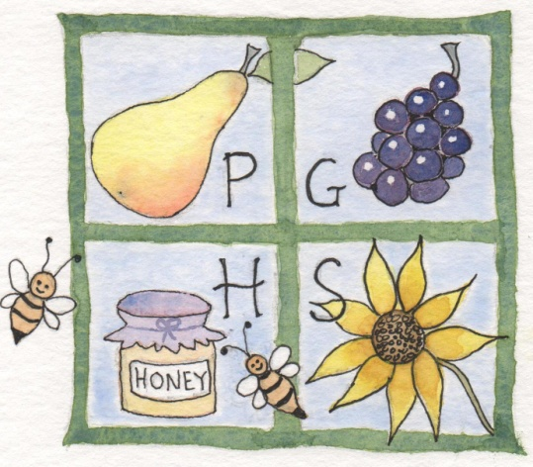

SHOW ENTRY FORM

SATURDAY 1ST AUGUST 2026

PARTRIDGE GREEN VILLAGE HALL

Staging 9.00am - 10.30am

Judging 11am

Doors open to the public at 2pm

www.pghorticulturalsociety.org
.

SUMMER SHOW ENTRY FORM 2026
Or enter online @ www.pghorticulturalsociety.org

Name of Exhibitor: ………………………………………………...................................

Address and Tel number: ...…………………………………………..……………………

No. of Classes entered ............................... Entry paid ...............................................

Contact no. & email address ........................................................................................

……………………….......................................................................................................

Entry fees: Members – 20p/Non members 40p. Children free
Late entries accepted BEFORE 10am on Saturday 1ST August @ 50p per entry

1 | 2 | 3 | 4 | 5 | 6 | 7 | 8 | 9 | 10
11 | 12 | 13 | 14 | 15 | 16 | 17 | 18 | 19 | 20
21 | 22 | 23 | 24 | 25 | 26 | 27 | 28 | 29 | 30
31 | 32 | 33 | 34 | 35 | 36 | 37 | 38 | 39 | 40
41 | 42 | 43 | 44 | 45 | 46 | 47 | 48 | 49 | 50
51 | 52 | 53 | 54 | 55 | 56 | 57 | 58 | 59 | 60
61 | 62 | 63 | 64 | 65 | 66 | 67 | 68 | 69 | 70
71 | 72 | 73 | 74 | 75 | 76 | 77 | 78 | 79 | 80
81 | 82 | 83 | 84 | 85 | 86 | 87 | 88 | 89 | 90
91 | 92 | 93 | 94 | 95 | 96 | 97 | 98 | 99 | 100
101 | 102 | 103 | 104 | 105 | 106

Please circle the classes you wish to enter and either post or hand-deliver your entry to one of the following BEFORE THURSDAY 30th JULY. One entry form per person please

Mrs L. Tate-Harte Mrs Marie Barker
Hedgeways, Mill Lane 53 Oakwood
Partridge Green. Partridge Green

I hereby agree to abide by the Rules of the Show and wish to exhibit in the class/classes as marked.

Signed:………………………………………….....................................................……….

REMEMBER Please box

Member

New member

Non member

